**COMPUTER HARDWARE AND**

**COMPUTER SOFTWARE**

**LAB# 01 & LAB# 02**

**

**BATCH# 24**

**FALL 2022**

**COMPUTER FUNDAMENTALS LAB**

**Submitted by: ALESHBA AAINA**

ETEA ID: 55012

Section: B

**“On my honor, as a student of UET, I have neither given nor received unauthorized assistance on this academic work.”**

**STUDENT SIGNATURE: ______________**

Submitted to:

**Engr. Abdullah Hamid**

25 NOVEMBER 2022

Department of Computer Systems Engineering

University of Engineering and Technology, Peshawar

**Task# 01: MY PERSONEL COMPUTER**

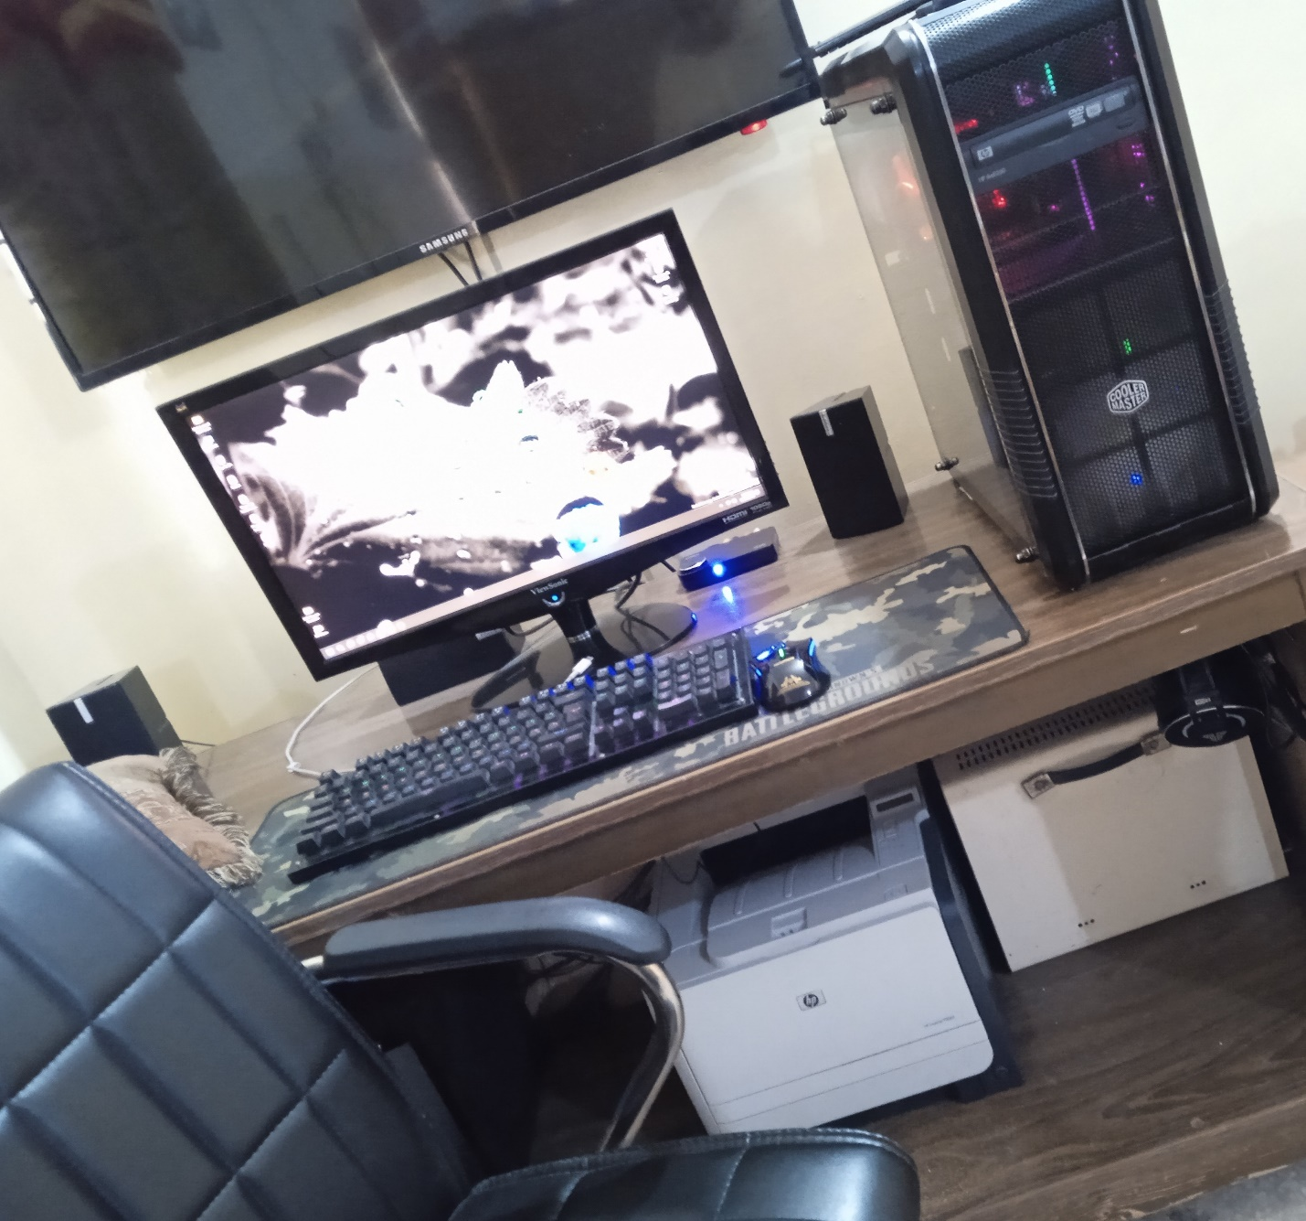

**DEVICE SPECIFICATIONS:**

* Processor: AMD Ryzen 2600
* RAM: T-Force Zues 32 MHz 16GB
* Primary Storage: 256GB NVME 2.0
* GPU: GTX 1060 6GB Zotac AMP
* Secondary Storage: 2TB Western Digital Black Series
* Power Supply Unit: Thermaltake 630 Watts Modular
* Motherboard: MSI Mortar Max B450
* Case: Cooler Master
* Cooling System: Cooler Master Hyper 212 EVO

**CONNECTED PERIPHERALS:**

* Keyboard: HP Pavilion 550 Gaming Keyboard
* Mouse: Newmen G7 Optical USB Gaming
* Headset: Fantech Octane HG23 Programmable
* Monitor: ViewSonic VX-57 MHD 1080p Full HD

**Task# 02:** **MY PHONE SPECS**

* SOC: MediaTek Helio G25
* CPU: Octacore 12nm
* Device Model: Redmi 10A
* Operating System: Android 11, MIUI 12.5
* Display Size: 6.53”
* Display Resolution: 720*1600 pixels
* Main Camera: 13 MP
* Selfie Camera: 5 MP
* RAM: 4GB
* Storage: 128GB
* Battery: Li-Ion 5000mAh
* GPU: PowerVR GE8320
* Color: Slate Grey

**Task# 03:** **INSTALLING WINDOWS**

1. Take any booting device like USB flashdrive and insert it into cmputer.
2. Restart the computer.
3. Wait for the computer to start show a message where it tells you to ‘press any key’ to boot the flash drive, when you press the key, the computer boots the USB instead of the hard drive.
4. Now wait for the installation process to begin. After few minutes the ‘Install Now’ prompt will appear. So click ‘Install Now’.
5. As its Followed by the Window’s Startup screen, Now enter the desired three options by selecting a language of choice and click ‘next’.
6. After that, now we have to select an operating system with it’s specific architecture.
7. Finally agree to the license terms and select the installation type for example, upgraded-type or customized-type.
8. Now manually cutomize and select a partition drive for letting the installer know where disk the windows files will be copied.
9. Finally, click ‘Next’ to start the Installation.
10. Now the Setup is being installed. And it’s just a matter of time that the setup finishes and then you customizeyour account, PC name, password and few more data and hence the installation process is completed.

**Step 3:**

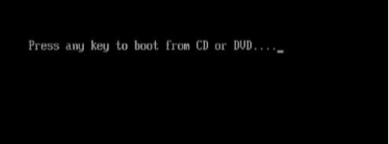

**Step 4:**

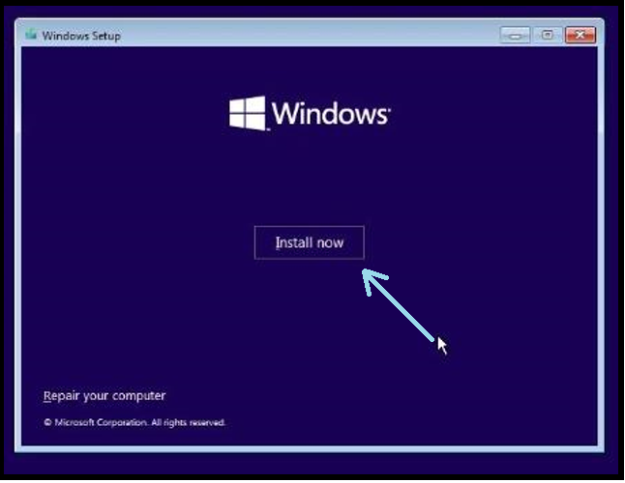

**Step 5:**

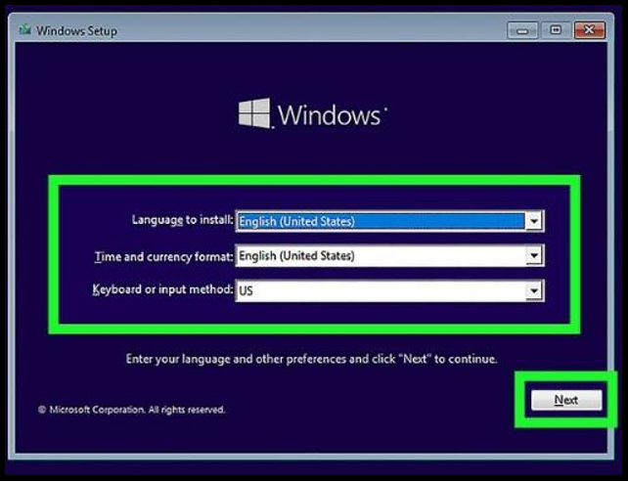

**Step 6:**

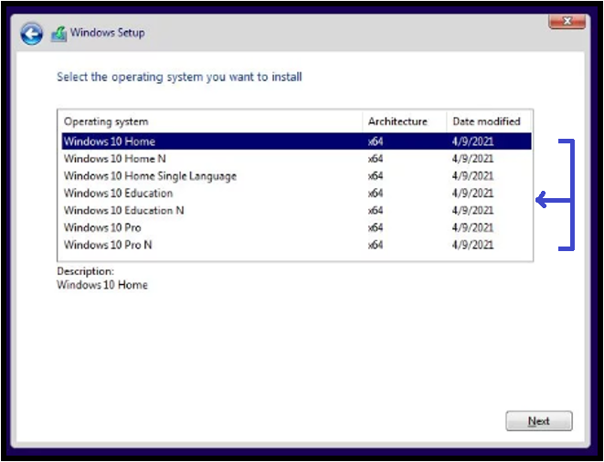

**Step 7:**

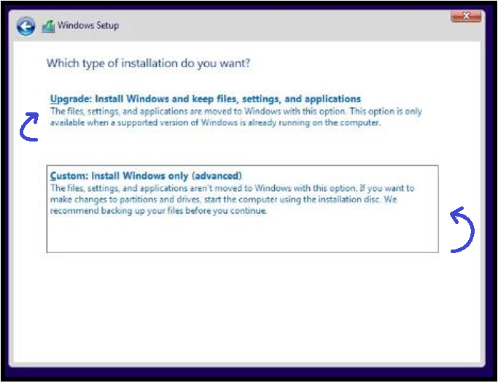

**Step 8:**

